Huynh Van Anh

La Tran Hai Dang

Pham Gia Nguyen

Trinh Quang Minh

### Team Profile

**Personal Information**

* Huynh Van Anh

My full name is Huynh Van Anh, and my student ID is 3836320. I come from Vinh Long City, after graduating from Nguyen Binh Khiem High School, I am now studying at RMIT University. Previously, I was a student specializing in Chemistry. Instead of choosing to become a doctor or pharmacist, I followed my passion and became a member of SST (School of Science and Technology). I have a great curiosity to explore the Data Industry, and I expect to be a Data Scientist. Our team name is called '4tech', which stands for 'Four for Technology.' It is also similar to our Project Idea product's name.

* La Tran Hai Dang

Firstly, I will introduce some information about myself. My full name is La Tran Hai Dang and my student number is s3836605. I have been living and studying in District 1 of Ho Chi Minh City for 20 years. Currently, I am a second-year student with my first semester in major that is a bachelor of information technology at RMIT Vietnam University. For me, the field of science and technology, especially information technology, has brought me the passion to learn new knowledge by the vastness of the IT world. I first encountered programming in grade 8, when it was the pascal programming language as an official subject in the school curriculum. I was intrigued by the command lines and the magic of computer algorithms. Since then, I have decided to enter the computer science class at high school and have achieved the silver medal for good students in IT. Besides, not only interested in technology but also music for example playing instruments and participating in volunteer activities are my hobbies. I hope that the time I spend studying and researching information technology will help me improve my professional knowledge and hands-on experience in the technology industry.

* Pham Gia Nguyen

My name is Pham Gia Nguyen, my student ID is s2819521. Ho Chi Minh city is where I was born and grew up. Currently, in 2020, I am studying Information Technology program at RMIT with specialising in web development because I want to be a full-stack developer and mobile developer. In the past, I used to have a strong passion for football and swimming because I can connect closer to my friends and I can train myself. I have won a championship in a competition in high school. I have to admit that it is the best experience and exciting during my high school lifetime. However, my passion for IT became large when I saw my big brother, a competitive programmer, solving many challenging database problems such as arrays, multidimensional arrays and matrices in an online contest every weekend. Then, I follow his path to solving problems on the Leetcode website and join a contest at the weekends.

* Trinh Quang Minh

My name is Trinh Quang Minh. My student ID is s3848088. I am Vietnamese, born in Ho Chi Minh city and I’ve spent three years studying abroad in Sydney, Australia and graduated high school there. My hobbies are playing an instrument (piano and guitar), listening to music, and playing games. I like playing games and I’m curious about how they operate behind the scenes. I also like to sit on my computer doing research, so I think doing IT is suitable for me. I’ve had the basic knowledge about coding in Python 3.0+ as it was a part of the study program that I took part in.

**Team Profile**

* Huynh Van Anh

Test Outcomes:

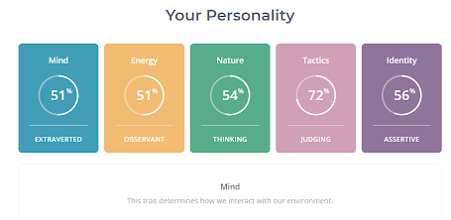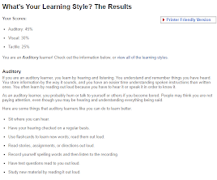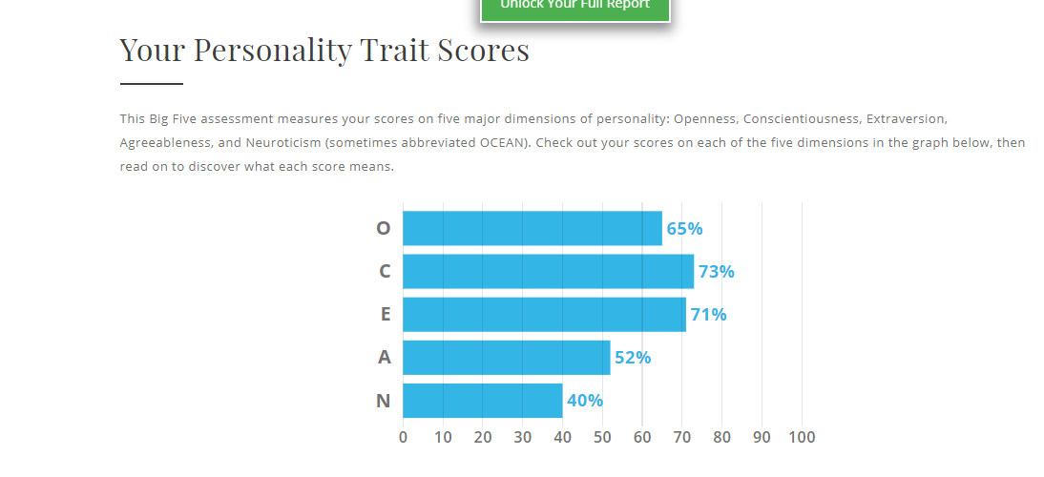

Because of having an ability to observe, pay attention to others. It is a high score for teamwork; moreover, the second point is being a decisive person in decisions. I confidently arrange the task and timeline to complete the work for our team. As an effective learner by hearing, I have a tendency to listen and synthesize different ideas before progressing a final decision. With all of the above, I believe that my good sides can play a crucial role in our group.

* La Tran Hai Dang

Test outcomes: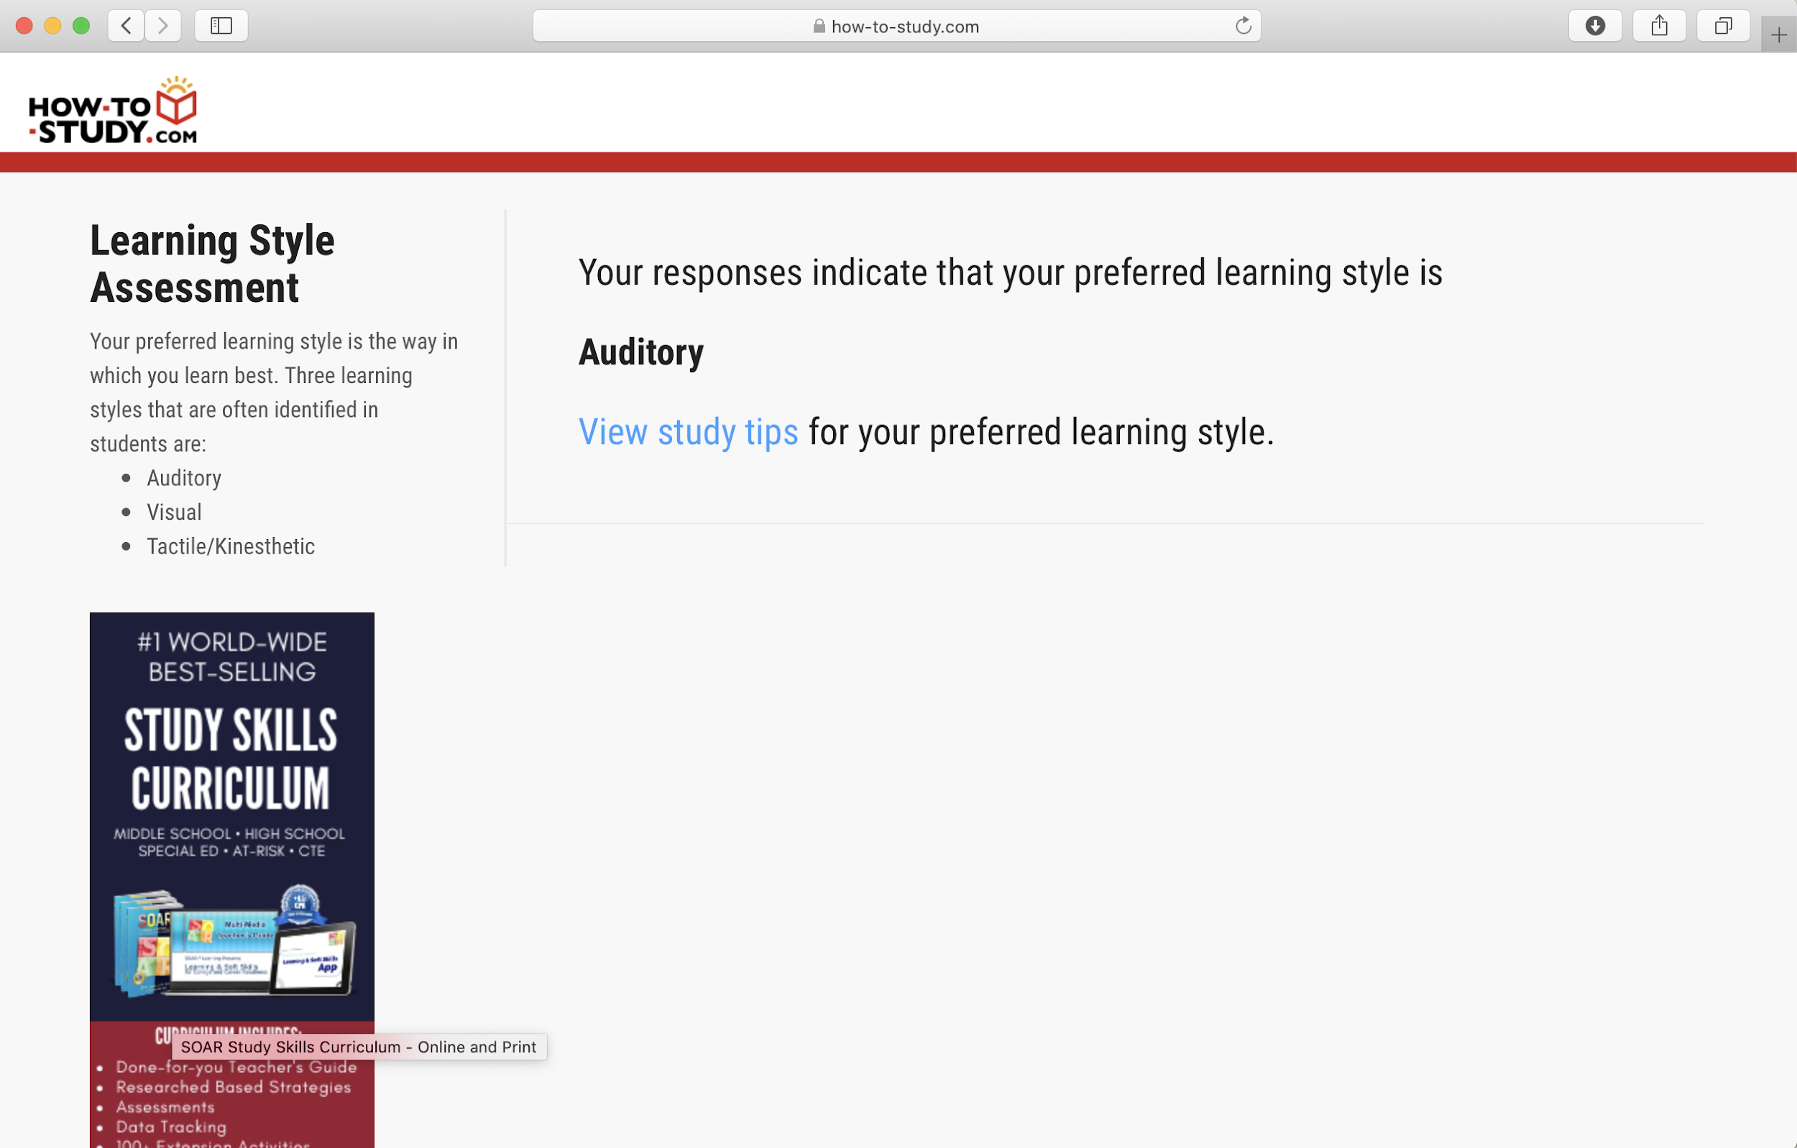

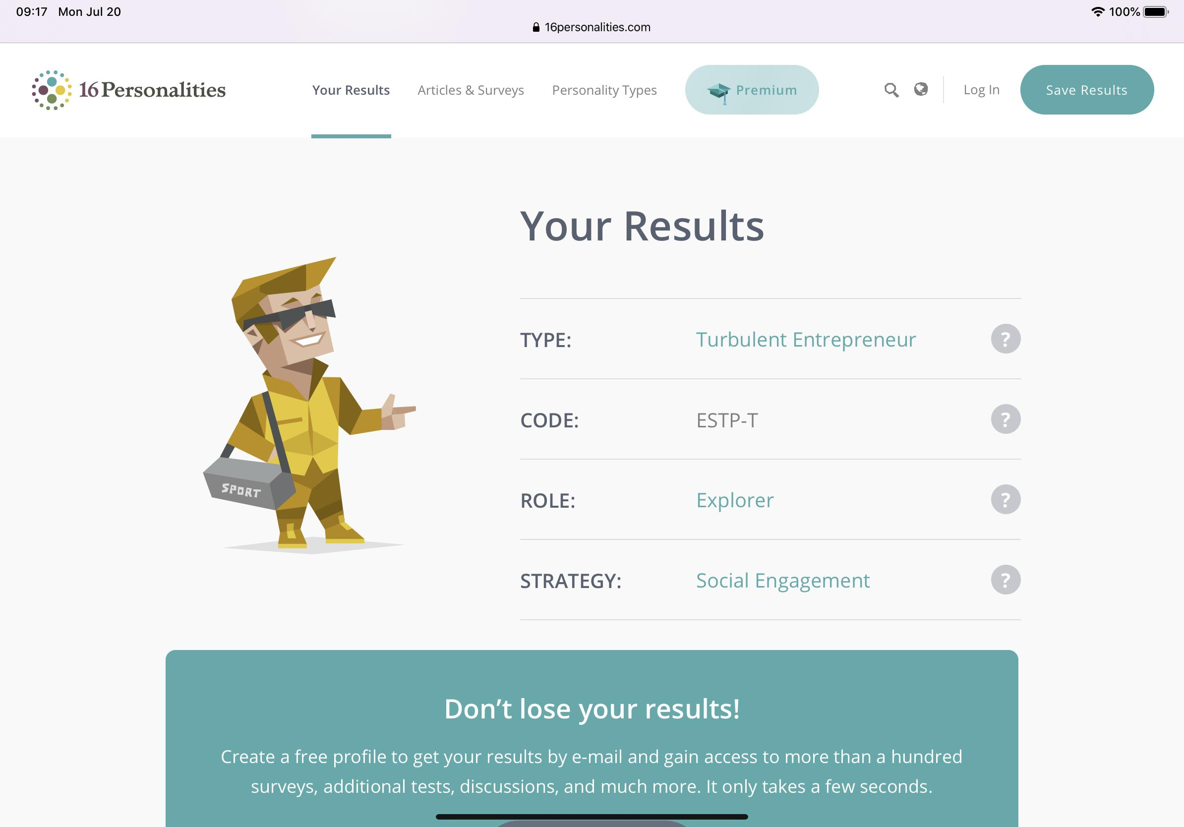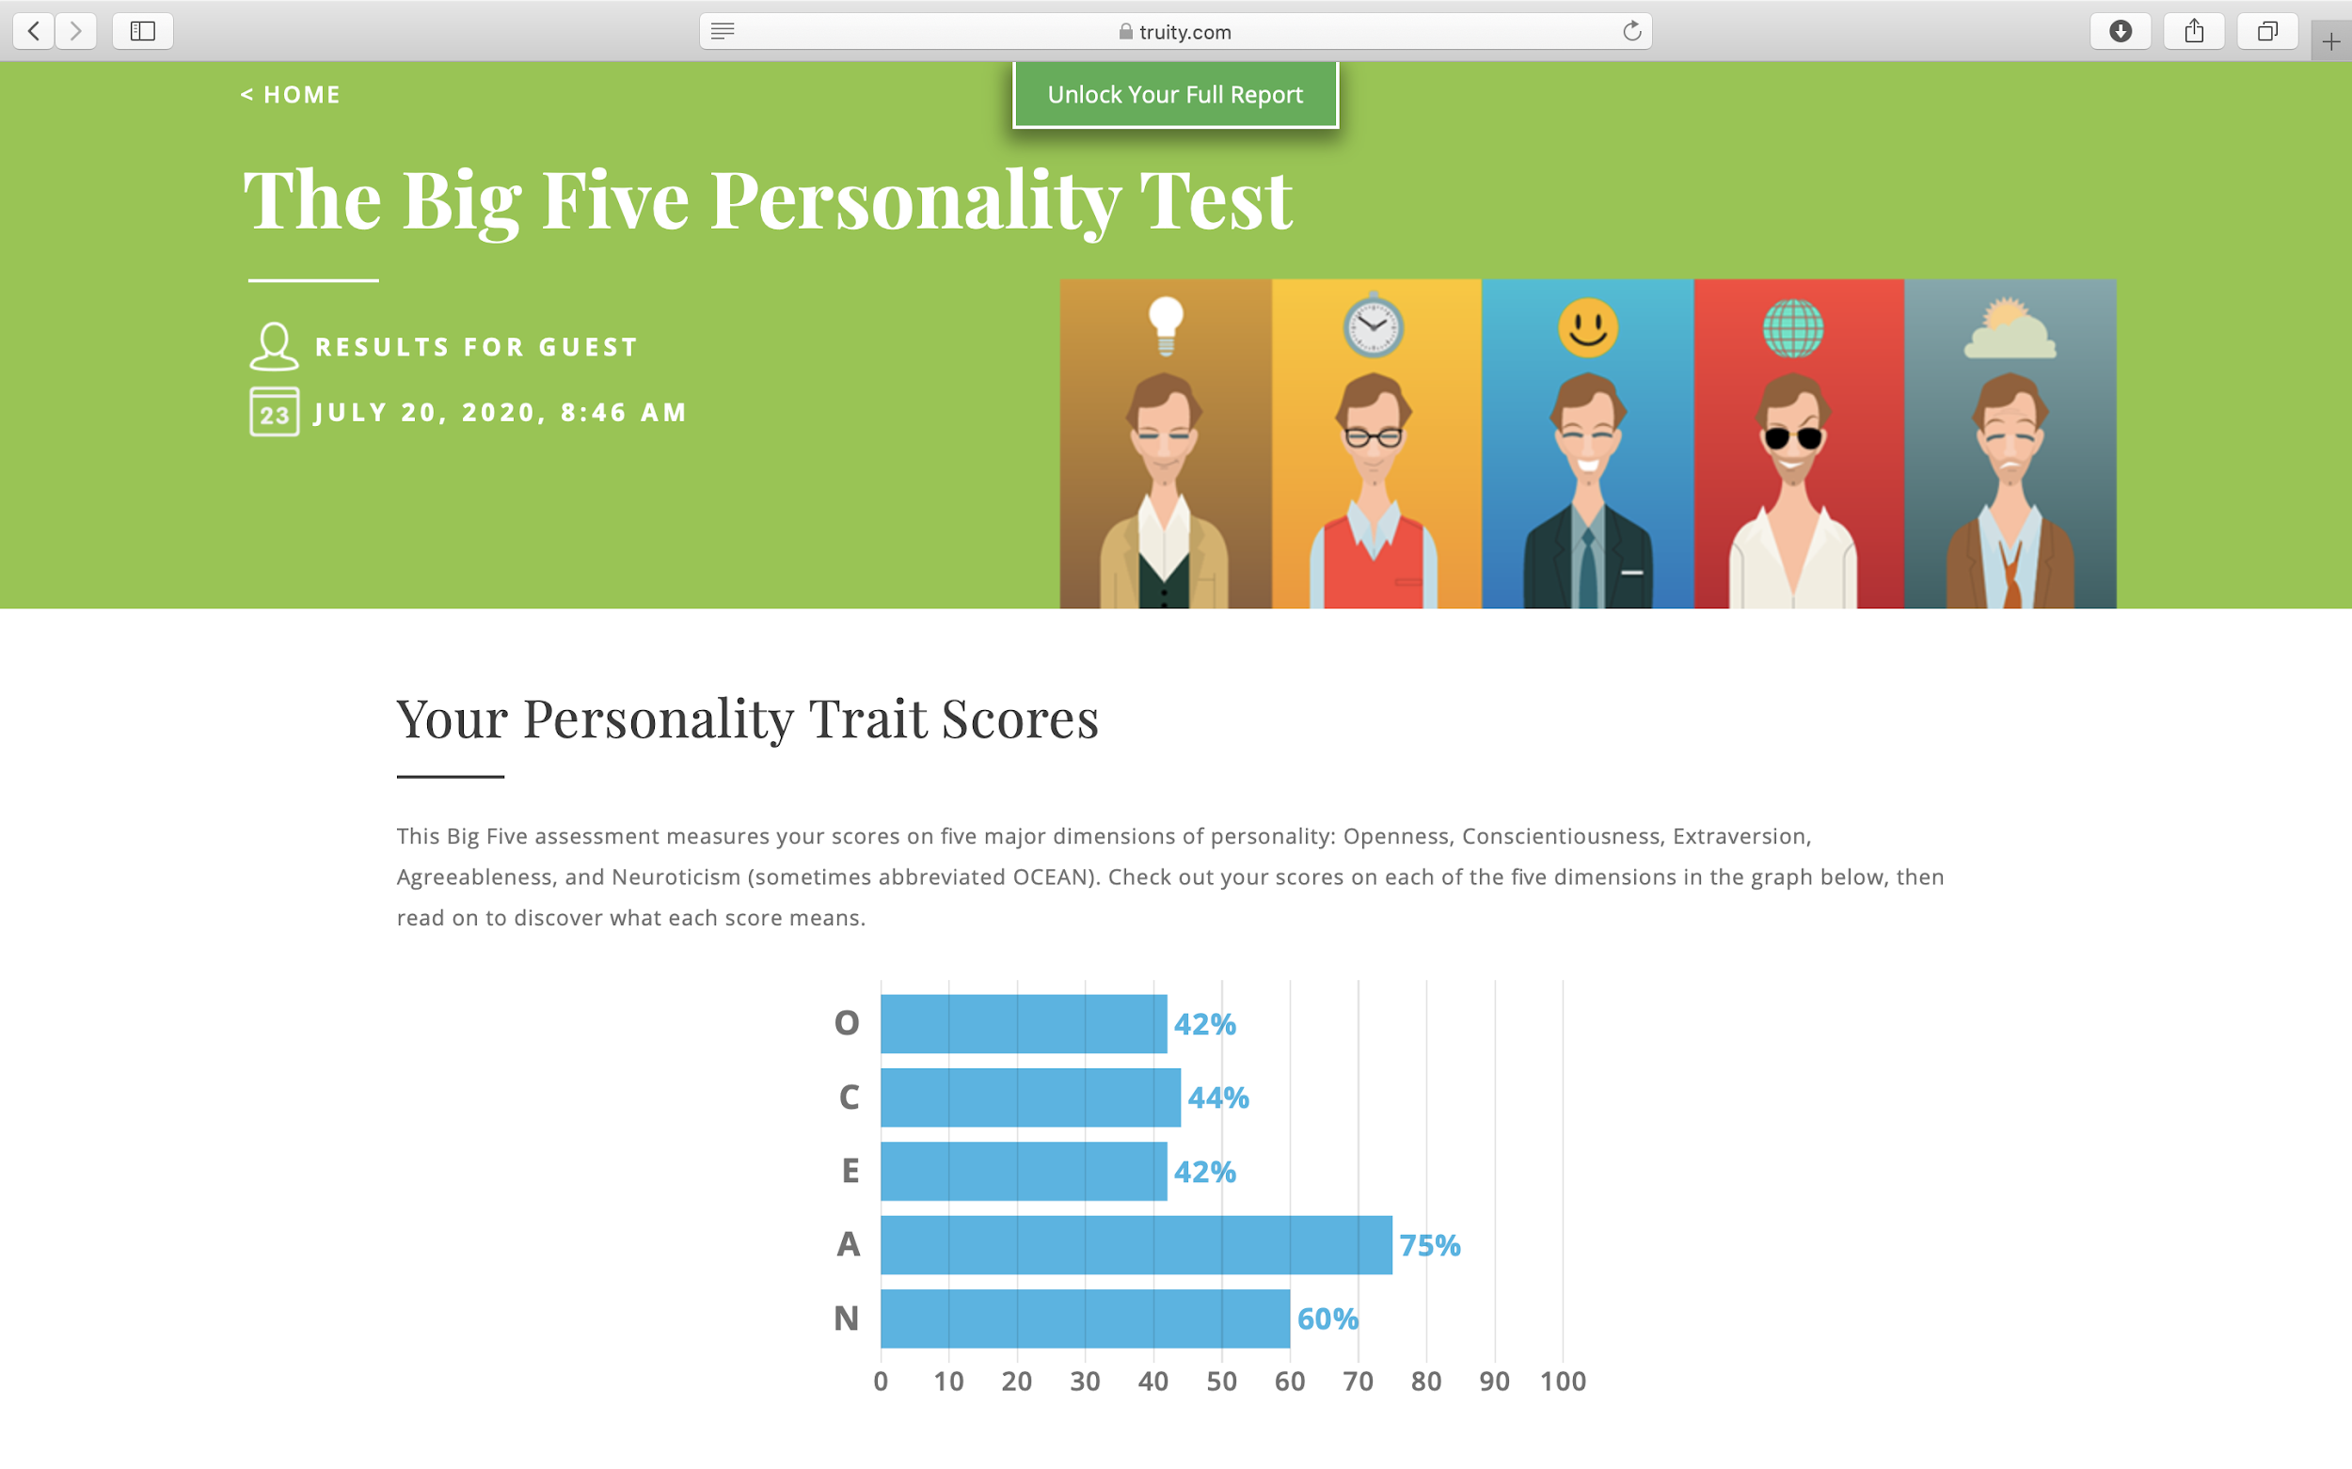

When working in a team, one of the skills needed to get the most out of a job is listening. Based on the results of my learning style test, the auditory learning style allowed me to easily listen and understand the opinions of the group members. I am a practical and appropriate person to solve difficult group problems in a flexible way instead of working with boring theory. Besides, with good observation and ability to communicate I will be one of the connections that help the team can work together comfortably. Also, as a result of my personality test and Myers-Briggs, I always have a positive and responsible energy in my assigned work. This is important and necessary in team work because it brings dynamism, respect, contribution, and improvement of strengths and weaknesses to achieve the goals set by the group.

* Pham Gia Nguyen

Test outcomes:

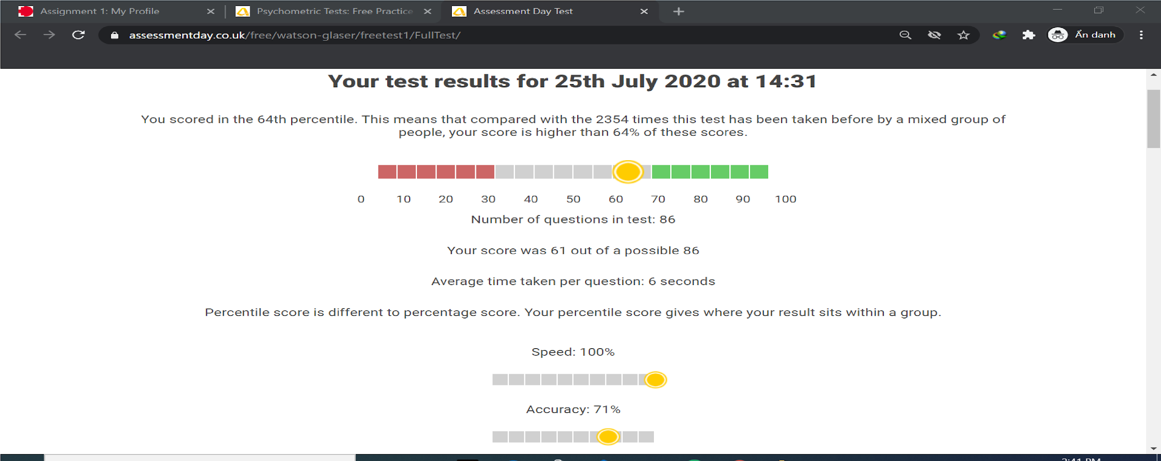

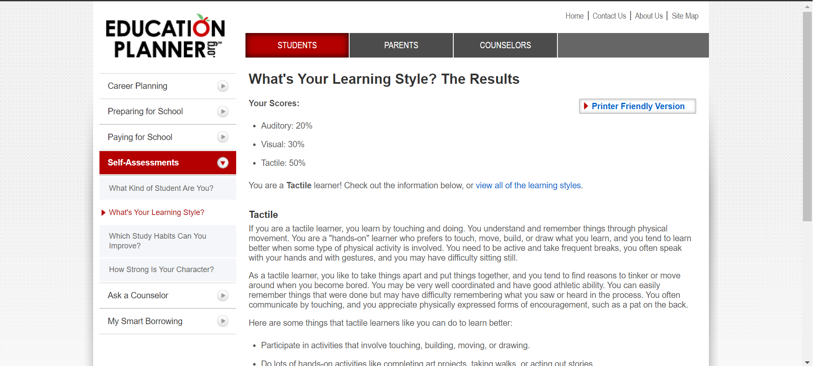

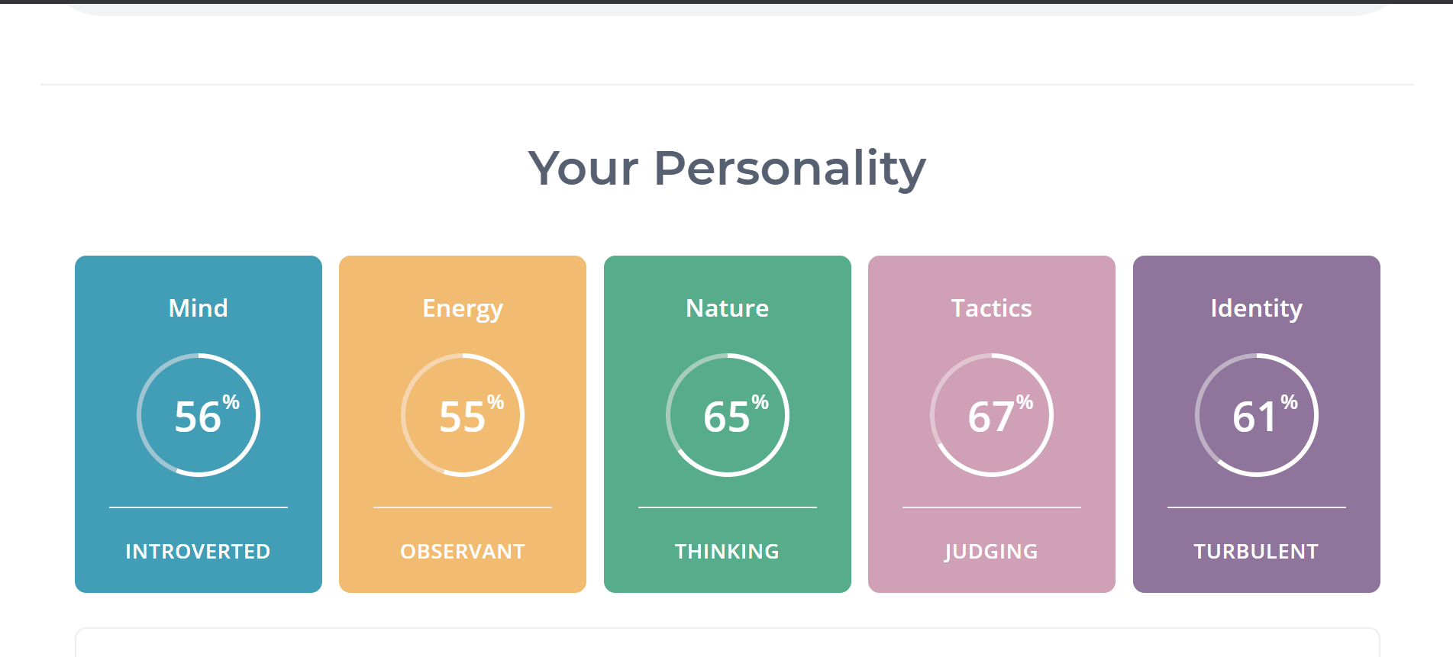

Being critical thinking and judging, I can provide useful solutions and sources of the information for the projects with high accuracy. The outcomes will be affected by the decisions of each team member; therefore, having a good vision and judging can improve team performance. Also, I tend to learn by writing down, which I can remember much longer. It is great to share not only with my teammates but also for someone curious about what I have experienced and learnt.

* Trinh Quang Minh

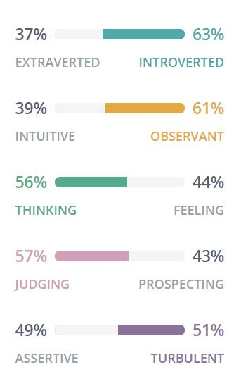

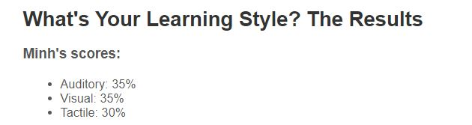

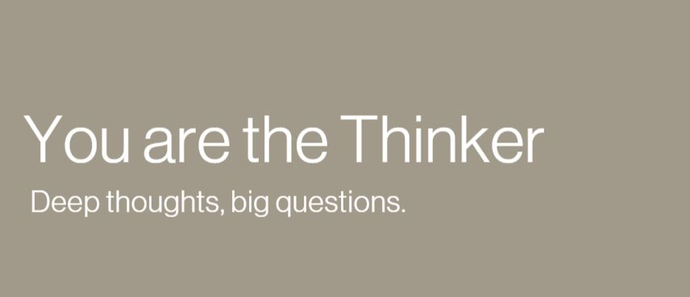

From the 3 tests’ results, I found out that I am more of an introverted person, so I and strong in the listening skill but I need to improve my communication skill much more to share ideas with my team as that is an important skill to have in order to bring the best results to the project

**Ideal Job**

* **Data Scientist:**
* Core skills:
* Fluent in programming languages ​​and data queries such as Python, Pandas, Numpy, My SQL, Oracle, SQL.
* Some skills related to the specialized work of Data Scientist such as Data Visualization and Communication, Statistics, Data Wrangling, Data Intuition.
* Soft skill:
* Communication : Ability to communicate with other people like teammates or customers.
* Teamwork and Collaboration skills
* Presentation: convey the results gathered in meetings
* Qualification:
* Bachelor's degree in Computer Science, Statistics, Economics, Information Technology.
* It would be great to have a Ph. D. or MSc in Data Science or Operations Research or Statistics or other quantitative fields.
* The experience required:
* More than 3 years working in a position related to data science.
* Fluent in programming skills and fluent in the libraries and frameworks available.
* Vital knowledge in mySQL, SQL and Python, PySpark and Scala.
* **IT OFFICER:**
* The skills:
* Good understanding of the mobile device, computer system and other endpoint tech products.
* Able to communicate in English.
* Good communication and critical thinking skills.
* Adaptive capacity in an open working environment, easily creating good relationships with customers is a plus.
* Teamwork skills and support to promote effective work development with the IT team.
* The experiences:
* Having experience in the Education Industry.
* Required for diagnostic skills and solve technical problems.
* The willingness, passion, enthusiasm, and to learn new technology in a fluid and fast-paced environment.
* Have technique and practice for client enquiries, troubleshooting and problem resolution and prioritization.
* Tech savvy with working knowledge of office 365, PC Computing, Basic Networking, Printing, Drive Network, Antivirus on Client Side, Update at Client Side.
* The qualifications:
* Degree or Bachelor of Information Technology/ relevant to the computer system.
* Having CCNA, MCSA, MCSE, LPI certificates are preferable.
* PMI Agile Certified Practitioner (PMI-ACP).
* Microsoft Office Specialist (MOS) Certification.
* **Web developer**
* The core skills and experiences:

+ 3 years of experience working as a Fullstack / Software Developer

+ Experience HTML, CSS, Javascript

+ Familiar with framework and library for the front-end: React, Vue.js, Angular

+ Experience with programming languages and back-end such as Java, PHP, Python, JavaScript (NodeJS)

+ Experience with APIs

+ Experience with Amazon Web Services (AWS) platform

+ Experience with SQL such as MySQL, SQL Server for storing the database

+ Experience with NoSQL database

* Soft skills:

+ Be able to work with other engineers in teams to promote technology and ensure consistency of the system.

+ Can provide recommendation and advice for continuous improvement.

+ Be able to work independently and collaborate with other team members to fulfil team results.

+ Communicate in English

* Qualification:
* **Software Engineer**
* The skill:

+ Teamwork is highly required.

+ Strong in data structures, algorithm, storage systems and problem solving

+ Excellent software development skills in multiple languages and environments: Python, NodeJS, Java, Scala…

+ Experience in Machine Learning / Deep Learning is a plus.

+ Experience with third-party libraries and APIs.

* The Experience:

+ 2+ years of experience with high-traffic distributed systems and client-server architectures

+ Minimum 3 years of experience working in C#

+ Experience building complex and impactful software in a team environment

* The Qualification:

+ Minimum bachelor’s degree in computer science, programming, mathematics, or a related field.

+ Master a variety of programming languages such as: C++, C#, JavaScript, and Python and practice building software.

* Ability to adapt quickly to an existing, complex environment.

### Tools

* Link of the group’s website:
* Link of the group’s repository: <https://github.com/dangtran862000/Group-Project>
* Comment:

**Your comments on how well the audit trail on the Git repository reflects your group’s work. You will presumably only be able to do this close to the time of submission**

### Industry Data

Job Titles for group’s ideal jobs ranked in terms of demand from employers:

* Trinh Quang Minh - Software Engineer
* Phạm Gia Nguyễn - Web Developer
* La Tran Hai Dang - IT officer
* Huynh Van Anh - Data Scientist

**Group**

*How do the ​IT-specific skills​ in your required skill set rank in terms of demand from employers?*

1. JavaScript
2. Python
3. Java
4. SQL

*How do the​ general skills​ in your required skill set rank in terms of demand from employers?*

1. Communication skills
2. Problem solving
3. Critical thinking

*What are the three highest-ranked ​IT-specific skills​ which are not in your required skill set?*

1. SAP
2. Graphic Design
3. Microsoft Windows

*What are the three highest-ranked ​general skills​ which are not in your required skill set?*

1. Writing
2. Planning
3. Multi-Tasking

* **Huynh Van Anh - Data Scientist**

*How do the ​IT-specific skills​ in your required skill set rank in terms of demand from employers?*

1. SQL
2. Python
3. R language

*How do the​ general skills​ in your required skill set rank in terms of demand from employers?*

1. Problem Solving
2. Presentation Skills
3. Analytical Skills

*What are the three highest-ranked ​IT-specific skills​ which are not in your required skill set?*

1. JavaScripts
2. C#
3. C++

*What are the three highest-ranked ​general skills​ which are not in your required skill set?*

1. Writing
2. Troubleshooting
3. Multi-Tasking

*Having looked at the Burning Glass data, has your opinion of your ideal job changed? Why or why not?*

After consulting the information provided by Burning Glass Data, I still have not changed the viewpoint of my ideal Job. The following are additional analyzes for the above statement:

* The Specialised Skills listed Python with the low employers' demand and without the existence of the R programming language. However, according to the information provided by the Online data science community Kaggle's annual survey, “ Python is utilized by 76.3% of respondents and R by 59.2%” . [1]. So Python and R still play a crucial role in the Data area.
* Presentation skills, as well as Analytical skills, support Data scientists to demonstrate their results with other teams and customers who cannot 'read' the statistic.

Although the Data Science Job was not listed as a high demand job in the Burning Burning Glass Data 2018, I still love to do this job because of my passion for data, and I believe in the future with rapid development, the demand for employers to data also increases.

[1]: <https://towardsdatascience.com/training-your-staff-in-data-science-heres-how-to-pick-the-right-programming-language-dda349354b18>

* **La Tran Hai Dang - IT officer**

*How do the ​IT-specific skills​ in your required skill set rank in terms of demand from employers?*

1. Python
2. HTML/CSS
3. Javascript
4. UI/UX

*How do the​ general skills​ in your required skill set rank in terms of demand from employers?*

1. Critical thinking
2. Communication skills

## Analytical skills

1. Organisation and planning strategic

*What are the three highest-ranked ​IT-specific skills​ which are not in your required skill set?*

1. IT project management
2. Problem solving abilities
3. Programming skills
4. Technology support and IT Service desk

*What are the three highest-ranked ​general skills​ which are not in your required skill set?*

1. Teamwork and collaboration
2. Communication skills
3. Problem solving
4. Writing

*Having looked at the Burning Glass data, has your opinion of your ideal job changed? Why or why not?*

In general, IT staff play an important role in monitoring and maintaining the operation of computers and networks of an organization or enterprise. In the era of technology 4.0, the emergence of new technologies in everyday work requires someone to install, diagnose software and hardware failures, and resolve these technical problems.

The work is as well as general knowledge about how computer systems are used and applying technical understanding relevant to computer software or hardware. For other IT students, their ideal job is usually an application developer, a website developer or one of the other specific IT fields. But for me this is considered an ideal job because it gives me an overview of a big picture of the world of technology instead of just focusing on a specific field.

After consulting the Burning Glass data, I decided I would not change this ideal job because of the opportunities that this job offers me. This work provides a dynamic, comfortable and professional working environment with no sitting at the desk all day. It opens up many possibilities for developing my skills, building relationships, updating new technologies, not just software and hardware, and training my English skills.

In short, this job will not bring a significant income and is not the dream job of many people. However, IT officers are an indispensable part of any business, who helps to bring about the smooth and balanced working of a computer system. Besides, this job creates a great career opportunity in the era of industrialization and modernization today.

* **Phạm Gia Nguyễn - Web Developer**

*How do the IT-specific skills in your required skill set rank in terms of demand from employers?*

1. JavaScript
2. SQL
3. Java
4. AWS

*How do the​ general skills​ in your required skill set rank in terms of demand from employers?*

1. Group working
2. Able to communicate in English
3. Problem-solving skill

*What are the three highest-ranked ​IT-specific skills​ which are not in your required skill set?*

1. Graphic Design
2. Machine Learning
3. SAP

*What are the three highest-ranked ​general skills​ which are not in your required skill set?*

1. Communication
2. Planning

*Having looked at the Burning Glass data, has your opinion of your ideal job changed? Why or why not?*

Obviously no, there is an enormous demand for constructing and developing websites to meet human's desires. Currently, around 1.8 billion websites are created with approximately 400 million active.

Although the job titles for web developers are around 381 in Australia in 2018, the number of websites are growing very fast. To be clear, it is not very reliable to use outdated-data to compare with the current jobs. There are so many web applications we use nowadays such as Facebook, Youtube, etc. Note that, for people who use computers, they preferably use a web-based platform, which is convenient to open multiple websites for doing their work and easier for searching for their likes. Therefore, seeing fewer jobs for a web developer in a country is not right as a whole.

Last but not least, the decentralizedweb will be the next era of web development, in which user's data will be owned by themselves and not collected by the organisation or company. Thus, jobs for a web developer will be in high demand.

* **Trinh Quang Minh - Software Engineer**

*How do the IT-specific skills in your required skill set rank in terms of demand from employers?*

1. Python
2. JavaScript
3. Java

*How do the general skills in your required skill set rank in terms of demand from employers?*

1. Teamwork
2. Communication skills
3. Critical thinking

*What are the three highest-ranked IT-specific skills which are not in your required skill set?*

1. SQL
2. JavaScript
3. Microsoft Windows

*Future demand skill:*

1. Project management
2. React
3. JavaScript

*What are the three highest-ranked general skills which are not in your required skill set?*

1. Organizational skills
2. Troubleshooting
3. Planning

Future demand skill:

1. Writing
2. QA/QC
3. Detail-orientated

*Having looked at the Burning Glass data, has your opinion of your ideal job changed? Why or why not?*

After looking at the Burning Glass data, my opinion on my ideal job has not changed. In my views, a Software Engineer is the one who has the ability to create new advanced, innovative products to help the community in various fields of life. This job required to have a high determination and a mindset of not giving up which I have as being a Software Engineer is considered to be one of the most stressful jobs. For me, being a Software Engineer is one dream I want to have come true in the future.

In my opinion, at this time of life where it is called the 4.0 ages, the age of technology, this is the time when the people want the most advanced and innovative technologies for their life. That becomes a big chance for developers to have their creativity to actually act and create products that can supply the needs for users and this is the time where different companies are trying to recruit the qualified employees to be a part of their families. Nowadays, thanks to the innovating of programming languages, they have come up with an easy high-level programming language called Python, which can be approachable by everyone at the biggest operating system (Microsoft Windows and MacOS). According to different surveys on coders of all ages, Python is easy to learn, and it can be really efficient as there are many different sources and libraries for users to work on their project. Even though in the Burning Glass data, Python is not one of the top biggest languages, these results were in March 2018 and now is August 2020, which means more than 2 years already and it is way different now.

Besides that, Software Engineers are the ones who bring needs in different areas of life into their products (medical, entertainment, etc.). Without these people, it is a big loss to a company when it comes to competing in this time era.